SAP Fiori Notifications – Part 1

14. Januar 2020 von *Igor Muntoreanu*

In this blog we will explain how to implement SAP Fiori Notifications on your system and provide some real Business Scenarios with the code snippets. So we start with the questions what are SAP Fiori Notifications?

Notifications in enterprise applications are an effective way to make users aware of situations that require their timely action or attention. Examples include workflow scenarios, such as the assignment of new purchase order approvals or a situation that has just arisen.

From Fiori 2.0, SAP Fiori Launchpad provides a Notifications area, by clicking the bell icon in the shell bar at the top right of the screen, that lets you know about important tasks and requests requiring your timely action or knowledge.

In the notifications popover, the user can order notifications in various ways, take action, and navigate to the source of a specific notification.

SAP Fiori Launchpad can consume notifications from the SAP Gateway Notification Channel, which is part of the SAP_GWFND software component. The SAP Gateway Notification Channel is a framework for applications to deliver notifications to end users through various channels.

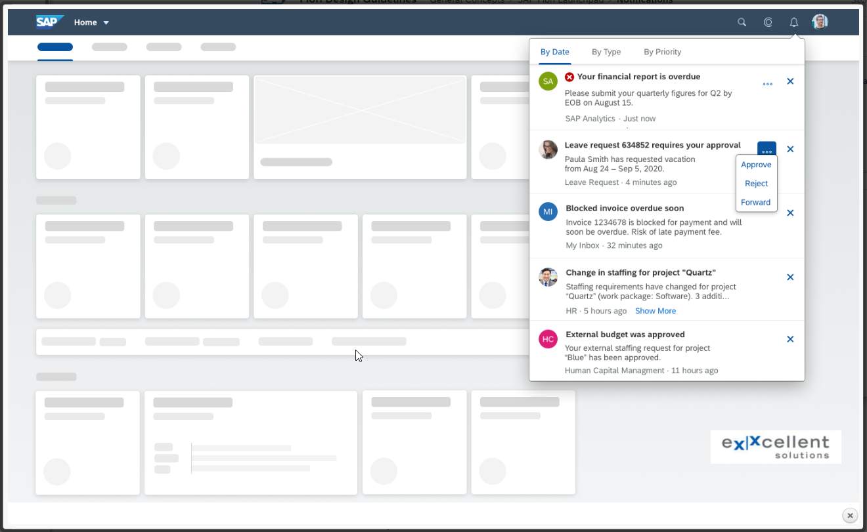

Prerequisites

The following prerequisites are required to get full usage of the Fiori Notifications:

* The component SAP_UI with version 751 SP00 and GWFND with version 7.51 SP00 or higher on the Notification Hub system.
* SAP_BASIS with version 7.51 SP01 or higher on the Backend system(See Note: [2356153](https://launchpad.support.sap.com/#/notes/2356153) - Business Workflow Extensions - Version 2)
* Fiori Launchpad is configured (see note [2456330](https://launchpad.support.sap.com/#/notes/2456330) - How to configure Fiori Launchpad step-by-step).
* If you want to use the workflow notification, Fiori My Inbox need to be configured(see note [2424054](https://launchpad.support.sap.com/#/notes/2424054) - How to setup My Inbox 2.0 app).

More details are described in the SAP Note: [2729492](https://launchpad.support.sap.com/#/notes/2729492).

Architecture  
  
The Launchpad consumes notifications from the notification channel, which is a Backendsystem that aggregates notifications from different notification providers configured in your environment:  
  
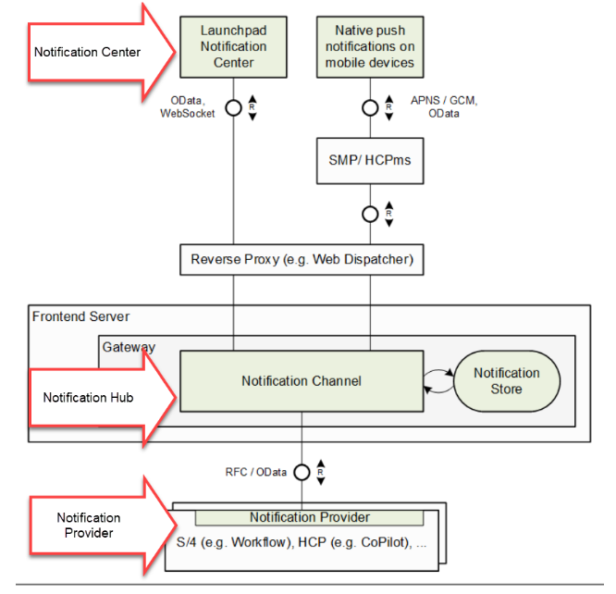  
*source:* [*https://wiki.scn.sap.com/wiki/display/SAPMOB/How+to+Setup+Notifications+in+Fiori+2.0+step-by-step*](https://wiki.scn.sap.com/wiki/display/SAPMOB/How+to+Setup+Notifications+in+Fiori+2.0+step-by-step)

There are three concepts to understand when activating notifications:

* Notification Center – the area in the Fiori Launchpad where notifications are displayed.
* Notification Hub – Collects notifications to be shown in the Notification Center.
* Notification Provider – Provides notification content to the Notification Hub.

The Notifications icon button is embedded in the shell bar and is the central access point for all notifications:  
  
  
  
Below we have an example of a list of notifications and the explanation of the schematic behind it:  
  
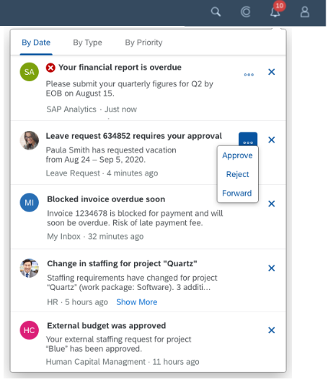

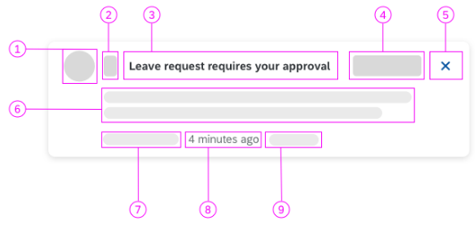

1. Image
2. Priority
3. Title
4. Action
5. Operation
6. Subtitle
7. Author/Source
8. Timestamp
9. Show/hide truncated text (Show More, Show Less)

The Schematic above is an example of the version 1.84 of the SAPUI5, depending of the version, the schematic can vary, to see more details about it, check the Fiori Guidelines at the following link: <https://experience.sap.com/fiori-design-web/notification-center/> .

Implementation  
  
There are mainly 4 steps to enable the Fiori Notifications:

* Creation and assignment of certain PFCG roles.
* Configuration of the Notification Hub.
* Configuration of the Notification Providers.
* Activation of the Notifications in the Fiori Launchpad.

Mainly all the configurations are performed at the SPRO transaction, under the path:  
  
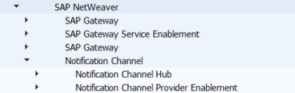  
  
All the steps above are very well documented in the SAP support website and can vary depending of your system version. To see the documentation, please check the note 2488945 at <https://launchpad.support.sap.com/#/notes/2488945>.

Technical Details

The notifications are collected from the Backend through the Service Id: /IWNGW/NOTIFICATION_SRV under the Service Group /IWNGW/NOTIFICATION. It was developed using the new approach of the OData v4 and can be seen under the transaction /IWFND/V4_ADMIN:  
  
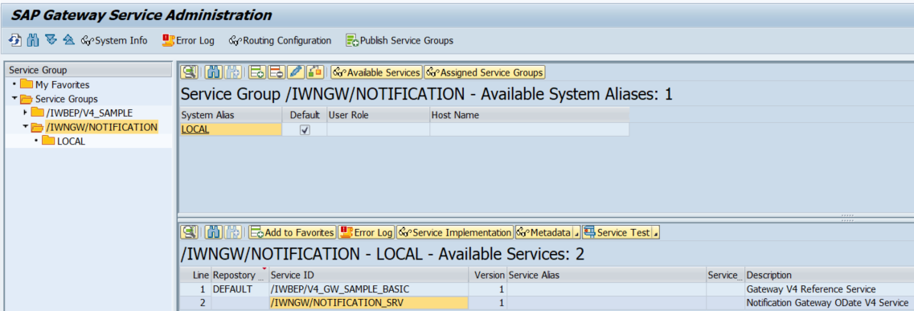

Getting even more deeply we have some database tables which handle and keep all the fiori notifications:

* /IWNGW/NOTIF - HUB Transactional - Notification Instance
* /IWNGW/NRECIP - HUB Transactional - Notification Recipients
* /IWNGW/NACTION - HUB Metadata - Notification Type Action
* /IWNGW/NTYPE - HUB Metadata - Notification Type Cache
* /IWNGW/NTYPE_TT - HUB Metadata - Notification Type Text Template

All the technical objects are stored inside the package /IWNGW/FRAMEWORK - SAP Notification Gateway Framework - Structure Package, and its subpackages:

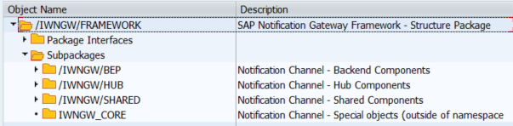

Real Business Case Scenario 1

In this scenario we have an Organizational Unit which has a Head of Department and also employees of the Sales Team:  
  
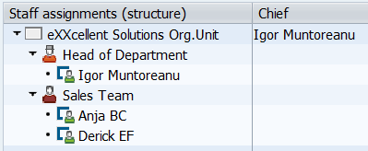  
  
The requirement is to send a notification to the Head of Department always when a Sales Order is adjusted or created by someone of the Sales Team.

As an example the following sales order was created by Derick, sap user DEF and then the Head of Department has checked on his Fiori Launchpad the received Notification:

* Sales order created trough transaction VA01  
  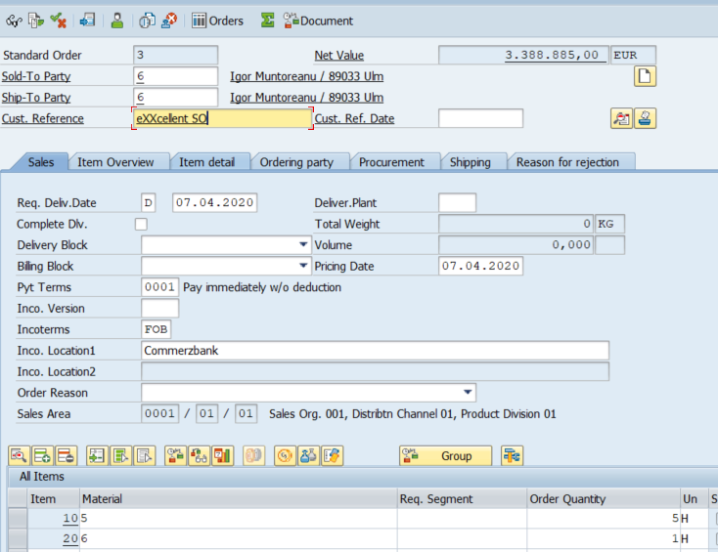
* Notification on the Fiori Lauchpad of the Head of Department:  
  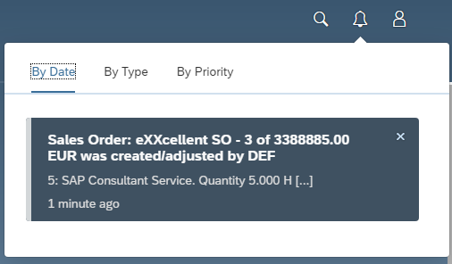

This notification is segmented in 2 parts: title and subtitle. Both have informations from the sales order. Here is how the title and subtitle were technically mapped:

|  |  |
| --- | --- |
| **Text** | **Table Source** |
| Sales Order: &1 - &2 of &3 &4 was created/adjusted by &5 | &1: VBAK-BSTNK  &2: VBAK-VBELN  &3: VBAK-NETWR  &4: VBAK-WAERK  &5: USER |
| &6: &7. Quantity &8 &9 [...] | &6: VBAP-MATNR  &7: VBAP-ARKTX  &8: VBAP-KWMENG  &9: VBAP-MEINS |

Technically, to implement this requirement the following 3 steps were implemented:

1. Configuration of the Notification Provider through the SPRO transaction:  
     
   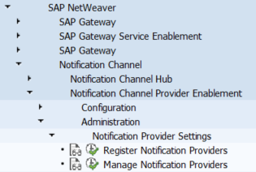  
     
   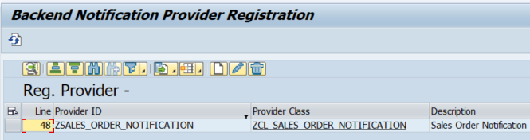  
     
   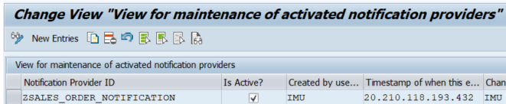
2. Implementation of the class ZCL_SALES_ORDER_NOTIFICATION:
   1. There are 2 ways to connect the class with the notification provider. One of them is to make the class /IWNGW/CL_NOTIF_PROVIDER_ABS as super class, this way implementing the interface /IWNGW/IF_NOTIF_PROVIDER_EXT or to just by assigning the class /IWNGW/IF_NOTIF_PROVIDER to the class. In this example we have done the first way:  
      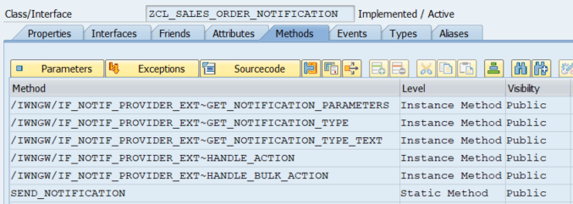
   2. Method /IWNGW/IF_NOTIF_PROVIDER_EXT~GET_NOTIFICATION_TYPE:

|  |
| --- |
| METHOD /iwngw/if_notif_provider_ext~get_notification_type.    es_notification_type-is_groupable = abap_true.   es_notification_type-type_key     = iv_type_key.   es_notification_type-version      = iv_type_version.  ENDMETHOD. |

* 1. Method /IWNGW/IF_NOTIF_PROVIDER_EXT~GET_NOTIFICATION_TYPE_TEXT

|  |
| --- |
| METHOD /iwngw/if_notif_provider_ext~get_notification_type_text.    DATA: lv_text       TYPE string,         lv_subtitle   TYPE string,         ls_type_text  TYPE /iwngw/if_notif_provider_ext=>ty_s_notification_type_text.    lv_text = TEXT-001. "Sales Order: XVBAK-BSTNK - VBAK-VBELN of VBAK-NETWR was created/adjusted by USER"   lv_subtitle = TEXT-003. "XVBAP-MATNR: XVBAP-ARKTX. Quantity XVBAP-KWMENG XVBAP-MEINS    REPLACE '&1' WITH '{VBAK-BSTNK}'  INTO lv_text.   REPLACE '&2' WITH '{VBAK-VBELN}'  INTO lv_text.   REPLACE '&3' WITH '{VBAK-NETWR}'  INTO lv_text.   REPLACE '&4' WITH '{VBAK-WAERK}'  INTO lv_text.   REPLACE '&5' WITH '{USER}'  INTO lv_text.   REPLACE '&6' WITH '{VBAP-MATNR}'  INTO lv_subtitle.   REPLACE '&7' WITH '{VBAP-ARKTX}'  INTO lv_subtitle.   REPLACE '&8' WITH '{VBAP-KWMENG}' INTO lv_subtitle.   REPLACE '&9' WITH '{VBAP-MEINS}'  INTO lv_subtitle.    ls_type_text-name  = /iwngw/if_notif_provider_ext=>gc_template_names-template_public.   ls_type_text-value = lv_text.   APPEND ls_type_text TO et_type_text.    ls_type_text-name  = /iwngw/if_notif_provider_ext=>gc_template_names-template_sensitive.   ls_type_text-value = lv_text.   APPEND ls_type_text TO et_type_text.    ls_type_text-name  = /iwngw/if_notif_provider_ext=>gc_template_names-template_grouped.   ls_type_text-value = TEXT-002. "Sales Order Notifications   APPEND ls_type_text TO et_type_text.    ls_type_text-name  = /iwngw/if_notif_provider_ext=>gc_template_names-subtitle.   ls_type_text-value = lv_subtitle. "Sales Order Notifications   APPEND ls_type_text TO et_type_text.  ENDMETHOD. |

* 1. Method SEND_NOTIFICATION

|  |
| --- |
| METHOD send_notification.    DATA: lt_nf               TYPE /iwngw/if_notif_provider=>ty_t_notification,         ls_nf               TYPE LINE OF /iwngw/if_notif_provider=>ty_t_notification,         lt_user             TYPE STANDARD TABLE OF /iwngw/if_notif_provider=>ty_s_notification_recipient,         ls_user             TYPE /iwngw/if_notif_provider=>ty_s_notification_recipient,         lt_parameter_values TYPE /iwngw/if_notif_provider=>ty_t_notification_parameter,         ls_parameter_values TYPE LINE OF /iwngw/if_notif_provider=>ty_t_notification_parameter,         ls_parameter        TYPE LINE OF /iwngw/if_notif_provider=>ty_t_notification_param_bundle,         lt_parameter        TYPE /iwngw/if_notif_provider=>ty_t_notification_param_bundle,         lt_objec            TYPE STANDARD TABLE OF objec.    FIELD-SYMBOLS: <fs_value> TYPE any.    "Get everyone from the Organization Unit   CALL FUNCTION 'RH_STRUC_GET'     EXPORTING       act_otype      = 'O'       act_objid      = '50000077' " eXXcellent Solutions Organization Unit       act_wegid      = 'AI_ORGUS' " All users of the Organization Unit     TABLES       result_objec   = lt_objec     EXCEPTIONS       no_plvar_found = 1       no_entry_found = 2       OTHERS         = 3.   IF sy-subrc = 0.     "Send notification only to the Head of Department     READ TABLE lt_objec TRANSPORTING NO FIELDS WITH KEY objid = '50000079'.     IF sy-subrc = 0.       DATA(lv_tabix) = sy-tabix + 1.       TRY.           DATA(ls_object) = lt_objec[ lv_tabix ].            CHECK sy-uname <> ls_object-realo. "Avoid the Head of sending the notification to himself            READ TABLE lt_objec TRANSPORTING NO FIELDS WITH KEY realo = sy-uname. "Make sure that the user is in the Organization Unit           IF sy-subrc = 0.              TRY.                 DATA(lv_system_uuid) = cl_uuid_factory=>create_system_uuid( ).                 ls_nf-id             = lv_system_uuid->create_uuid_x16( ).                  ls_user-id = ls_object-realo.                 APPEND ls_user TO lt_user. CLEAR ls_user.                  ls_nf-type_key                 = 'ZSALES_ORDER_NOTIFICATION'.                 ls_nf-type_version             = '9'.                 ls_nf-recipients               = lt_user[].                  ls_parameter_values-name         = 'USER'.                 ls_parameter_values-type         = 'Edm.String'.                 ls_parameter_values-value        = sy-uname.                 ls_parameter_values-is_sensitive = abap_false.                 APPEND ls_parameter_values TO lt_parameter_values. CLEAR: ls_parameter_values.                  ls_parameter_values-name         = 'VBAK-VBELN'.                 ls_parameter_values-type         = 'Edm.String'.                 ASSIGN COMPONENT 'VBELN' OF STRUCTURE is_xvbak TO <fs_value>.                 ls_parameter_values-value        = <fs_value>.                 SHIFT ls_parameter_values-value LEFT DELETING LEADING '0'.                 ls_parameter_values-is_sensitive = abap_false.                 APPEND ls_parameter_values TO lt_parameter_values. CLEAR: ls_parameter_values.                  ls_parameter_values-name         = 'VBAK-NETWR'.                 ls_parameter_values-type         = 'Edm.String'.                 ASSIGN COMPONENT 'NETWR' OF STRUCTURE is_xvbak TO <fs_value>.                 ls_parameter_values-value        = <fs_value>.                 ls_parameter_values-is_sensitive = abap_false.                 APPEND ls_parameter_values TO lt_parameter_values. CLEAR: ls_parameter_values.                  ls_parameter_values-name         = 'VBAK-WAERK'.                 ls_parameter_values-type         = 'Edm.String'.                 ASSIGN COMPONENT 'WAERK' OF STRUCTURE is_xvbak TO <fs_value>.                 ls_parameter_values-value        = <fs_value>.                 ls_parameter_values-is_sensitive = abap_false.                 APPEND ls_parameter_values TO lt_parameter_values. CLEAR: ls_parameter_values.                  ls_parameter_values-name         = 'VBAK-BSTNK'.                 ls_parameter_values-type         = 'Edm.String'.                 ASSIGN COMPONENT 'BSTNK' OF STRUCTURE is_xvbak TO <fs_value>.                 ls_parameter_values-value        = <fs_value>.                 ls_parameter_values-is_sensitive = abap_false.                 APPEND ls_parameter_values TO lt_parameter_values. CLEAR: ls_parameter_values.                  "Send only the first item to the notification                 READ TABLE it_xvbap ASSIGNING FIELD-SYMBOL(<fs_xvbap>) INDEX 1.                 IF sy-subrc = 0.                   ls_parameter_values-name         = 'VBAP-MATNR'.                   ls_parameter_values-type         = 'Edm.String'.                   ls_parameter_values-value        = <fs_xvbap>-matnr.                   SHIFT ls_parameter_values-value LEFT DELETING LEADING '0'.                   ls_parameter_values-is_sensitive = abap_false.                   APPEND ls_parameter_values TO lt_parameter_values. CLEAR: ls_parameter_values.                    ls_parameter_values-name         = 'VBAP-ARKTX'.                   ls_parameter_values-type         = 'Edm.String'.                   ls_parameter_values-value        = <fs_xvbap>-arktx.                   ls_parameter_values-is_sensitive = abap_false.                   APPEND ls_parameter_values TO lt_parameter_values. CLEAR: ls_parameter_values.                    ls_parameter_values-name         = 'VBAP-KWMENG'.                   ls_parameter_values-type         = 'Edm.String'.                   ls_parameter_values-value        = <fs_xvbap>-kwmeng.                   ls_parameter_values-is_sensitive = abap_false.                   APPEND ls_parameter_values TO lt_parameter_values. CLEAR: ls_parameter_values.                    ls_parameter_values-name         = 'VBAP-MEINS'.                   ls_parameter_values-type         = 'Edm.String'.                   ls_parameter_values-value        = <fs_xvbap>-meins.                   ls_parameter_values-is_sensitive = abap_false.                   APPEND ls_parameter_values TO lt_parameter_values. CLEAR: ls_parameter_values.                 ENDIF.                  ls_parameter-language            = sy-langu.                 ls_parameter-parameters          = lt_parameter_values.                 APPEND ls_parameter TO lt_parameter.                  ls_nf-parameters = lt_parameter[].                  APPEND ls_nf TO lt_nf.                  TRY.                     /iwngw/cl_notification_api=>create_notifications(                       EXPORTING                         iv_provider_id  = 'ZSALES_ORDER_NOTIFICATION' " class ZCL_GENERIC_NF_ANSWER                         it_notification = lt_nf ).                      COMMIT WORK AND WAIT.                    CATCH /iwngw/cx_notification_api INTO DATA(lrx_api).                     EXIT.                 ENDTRY.                CATCH cx_uuid_error.                 EXIT.             ENDTRY.           ENDIF.         CATCH cx_sy_itab_line_not_found.       ENDTRY.     ENDIF.   ENDIF.  ENDMETHOD. |

* 1. Text Elements  
       
     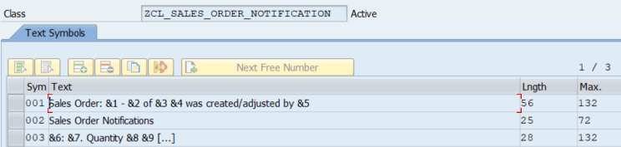

1. Implementation of the user exit “userexit_save_document“ at “mv45afzz“

|  |
| --- |
| FORM userexit_save_document.    zcl_sales_order_notification=>send_notification( EXPORTING is_xvbak = xvbak                                                              it_xvbap = xvbap[] ).  ENDFORM. |

Real Business Case Scenario 2

A requirement has arrived to send simple generic fiori notifications to certain users through an abap report, within specified date and time and its validity and priority. The user will receive the notification and will have 3 possiblities of answers: Accept, Maybe and Reject. As soon as the user answers the notification, a new notification will be sent to inform the owner of the users answer. Example:

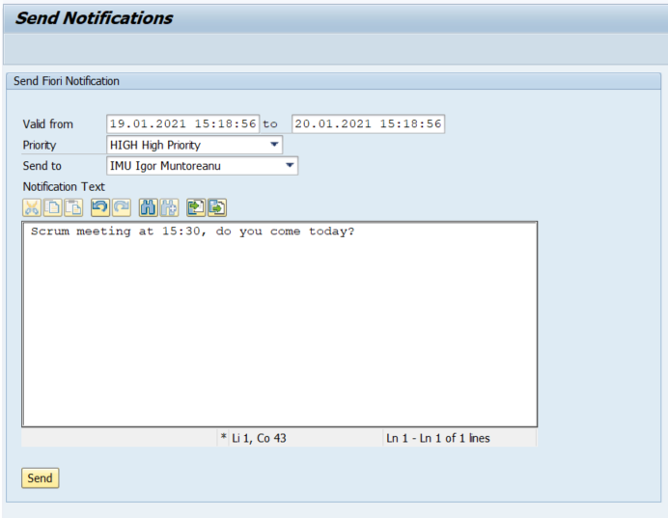

Notification received on the Fiori Launchpad for the user IMU:

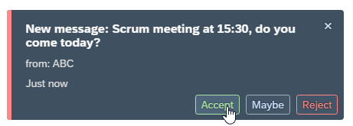

When he accepts the invitation, an action will be raised and will deliver the message back to the owner of the notification:  
  
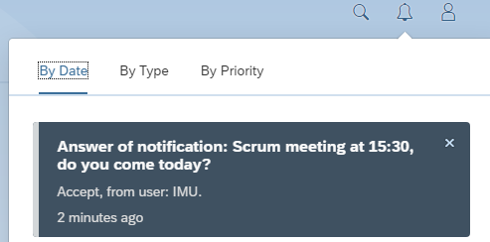

In the Abap Report, the user can plan the notification to be sent in the future, then a job is scheduled to send the notification at the specified time, that’s why have two extra tables to manage this behavior: ZEXX_NF and ZEXX_NF_NRECIP.

The following 5 steps were performed to implement this requirement:

1. Creation of 2 tables
   1. ZEXX_NF - Notifications for Fiori  
      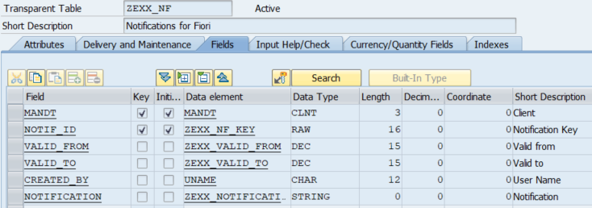
   2. ZEXX_NF_NRECIP - Notifications for Fiori Recipients  
      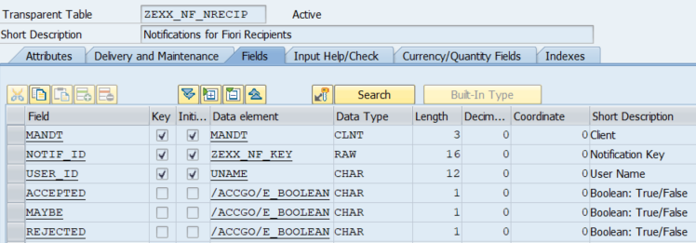
2. Report ZEXX_NOTIFICATION
   1. Body of the Report:

|  |
| --- |
| *&---------------------------------------------------------------------* *& Report ZEXX_NOTIFICATION *&---------------------------------------------------------------------* *& *&---------------------------------------------------------------------* REPORT zexx_notification.  INCLUDE zexx_notification_status_top. INCLUDE zexx_notification_status_pbo. INCLUDE zexx_notification_status_pai. INCLUDE zexx_notification_status_f01.  INITIALIZATION.   "check authorization   PERFORM f_check_authorization.    "check if provider active   PERFORM f_check_provider.  START-OF-SELECTION.    CALL SCREEN 0001. |

* 1. Include TOP: zexx_notification_status_top

|  |
| --- |
| *&---------------------------------------------------------------------* *& Include          ZEXX_NOTIFICATION_STATUS_TOP *&---------------------------------------------------------------------*    TYPE-POOLS: vrm.   "important: it must respect the size wordwrap_position          = 55 - check pbo   TYPES: ty_line_size TYPE c LENGTH 55.    DATA: *   reference to wrapper class of control     gv_editor           TYPE REF TO cl_gui_textedit,     gv_ok_code          TYPE sy-ucomm, *   reference to custom container: necessary to bind TextEdit Control     gv_editor_container TYPE REF TO cl_gui_custom_container,     gt_mytable          TYPE STANDARD TABLE OF ty_line_size,     gv_date_from        TYPE cpet_validfrom,     gv_date_to          TYPE cpet_validfrom,     gv_priority         TYPE /iwngw/notification_priority.  *   List box   DATA: gv_field   TYPE vrm_id,         gt_listbox TYPE vrm_values,         gs_listbox TYPE LINE OF vrm_values,         gs_user    TYPE uname.  *   Bapi User   DATA: gs_address TYPE bapiaddr3,         gt_return  TYPE STANDARD TABLE OF bapiret2. |

* 1. Include PBO: zexx_notification_status_pbo

|  |
| --- |
| *&---------------------------------------------------------------------* *& Include          ZEXX_NOTIFICATION_STATUS_PBO *&---------------------------------------------------------------------* *&---------------------------------------------------------------------* *&      Module  STATUS_0001  OUTPUT *&---------------------------------------------------------------------* *       text *----------------------------------------------------------------------* MODULE status_0001 OUTPUT.    DATA: lv_morgen TYPE sy-datum.    SET PF-STATUS 'MAIN100'.   SET TITLEBAR '0001'.    IF gv_date_from IS INITIAL.     gv_date_from = sy-datlo && sy-timlo.   ENDIF.    IF gv_date_to IS INITIAL.     lv_morgen = sy-datlo + 1.     gv_date_to = lv_morgen && sy-timlo.   ENDIF.    IF gv_editor IS INITIAL.  *   create control container     CREATE OBJECT gv_editor_container       EXPORTING         container_name              = 'GV_TEXT_EDITOR'       EXCEPTIONS         cntl_error                  = 1         cntl_system_error           = 2         create_error                = 3         lifetime_error              = 4         lifetime_dynpro_dynpro_link = 5.     IF sy-subrc EQ 0.  *   create calls constructor, which initializes, creats and links *   TextEdit Control       CREATE OBJECT gv_editor         EXPORTING           parent                     = gv_editor_container           wordwrap_mode              = cl_gui_textedit=>wordwrap_at_fixed_position           wordwrap_position          = 55           wordwrap_to_linebreak_mode = cl_gui_textedit=>true.        REFRESH gt_mytable.  " to initialize table upon OK_CODE 'BACK' at PAI      ENDIF.   ENDIF.    "Users Listbox:   REFRESH gt_listbox.   SELECT DISTINCT uname          FROM agr_users          INTO TABLE @DATA(gt_users)          WHERE agr_name = 'ZNTUSERPRODU'             OR agr_name = 'ZNTUSERCONSU'             OR agr_name = 'ZNTNPDEV'             OR agr_name = 'ZNTHUBADM'             OR agr_name = 'ZNTBEPADM'             AND from_dat <= @sy-datum             AND to_dat >= @sy-datum.   IF sy-subrc = 0.     LOOP AT gt_users INTO DATA(ls_users).       gs_listbox-key  = ls_users-uname.        CALL FUNCTION 'BAPI_USER_GET_DETAIL'         EXPORTING           username = ls_users-uname         IMPORTING           address  = gs_address         TABLES           return   = gt_return.        CONCATENATE gs_address-firstname gs_address-lastname INTO gs_listbox-text SEPARATED BY space.        APPEND gs_listbox TO gt_listbox. CLEAR gs_listbox.     ENDLOOP.      gs_listbox-key = '*'.     gs_listbox-text = text-006.     APPEND gs_listbox TO gt_listbox. CLEAR gs_listbox.      gv_field = 'GS_USER'.      CALL FUNCTION 'VRM_SET_VALUES'       EXPORTING         id     = gv_field         values = gt_listbox.    ENDIF.  ENDMODULE. |

* 1. Include PAI: zexx_notification_status_pai

|  |
| --- |
| *&---------------------------------------------------------------------* *& Include          ZEXX_NOTIFICATION_STATUS_PAI *&---------------------------------------------------------------------* *&---------------------------------------------------------------------* *&      Module  USER_COMMAND_0001  INPUT *&---------------------------------------------------------------------* MODULE user_command_0001 INPUT.   CASE gv_ok_code.     WHEN 'BACK' OR 'LEAVE' OR 'EXIT'. * Destroy Control.       IF NOT gv_editor IS INITIAL.         CALL METHOD gv_editor->free           EXCEPTIONS             OTHERS = 1.         IF sy-subrc NE 0.           FREE gv_editor.         ELSE. *   free ABAP object also           FREE gv_editor.         ENDIF.       ENDIF. * destroy container       IF NOT gv_editor_container IS INITIAL.         CALL METHOD gv_editor_container->free           EXCEPTIONS             OTHERS = 1.         IF sy-subrc EQ 0.           FREE gv_editor_container.         ELSE. *   free ABAP object also           FREE gv_editor_container.         ENDIF.       ENDIF.  * finally flush       CALL METHOD cl_gui_cfw=>flush         EXCEPTIONS           OTHERS = 1.       IF sy-subrc NE 0.         LEAVE PROGRAM.       ENDIF.       LEAVE PROGRAM.     WHEN 'SEND'.       PERFORM f_send_notification.     WHEN OTHERS.   ENDCASE.    CLEAR gv_ok_code.  ENDMODULE. |

* 1. Include F01: zexx_notification_status_f01

|  |
| --- |
| *&---------------------------------------------------------------------* *& Include          ZEXX_NOTIFICATION_STATUS_F01 *&---------------------------------------------------------------------* *&---------------------------------------------------------------------* *&  Include           /PBK/NOTIFICATION_STATUS_F01 *&---------------------------------------------------------------------* *&---------------------------------------------------------------------* *&      Form  F_SEND_NOTIFICATION *&---------------------------------------------------------------------* FORM f_send_notification .    DATA: ls_notification TYPE zexx_nf,         lt_selection    TYPE STANDARD TABLE OF rsparams,         ls_selection    TYPE rsparams.    IF gv_date_from IS INITIAL OR gv_date_to IS INITIAL.     MESSAGE TEXT-003 TYPE 'S' DISPLAY LIKE 'E'. "Fill the validity     EXIT.   ENDIF.    IF gs_user IS INITIAL.     MESSAGE TEXT-007 TYPE 'S' DISPLAY LIKE 'E'. "Select an user to receive the notification     EXIT.   ELSE.     ls_selection-selname = 'S_USER'.     ls_selection-kind    = 'S'. "Select Options = S     ls_selection-option  = COND #( WHEN gs_user = '*' THEN 'CP' ELSE 'EQ' ).     ls_selection-sign    = 'I'.     ls_selection-low     = gs_user.     APPEND ls_selection TO lt_selection. CLEAR ls_selection.    ENDIF.    IF gv_editor IS BOUND.      ls_notification-notif_id   = /iwngw/cl_med_util=>new_guid( ).     ls_notification-valid_from = gv_date_from.     ls_notification-valid_to   = gv_date_to.     ls_notification-created_by = sy-uname.      CALL METHOD gv_editor->get_text_as_r3table       IMPORTING         table = gt_mytable.      CONCATENATE LINES OF gt_mytable INTO ls_notification-notification SEPARATED BY cl_abap_char_utilities=>cr_lf.      INSERT zexx_nf FROM ls_notification.     IF sy-subrc = 0.        ls_selection-selname = 'P_ID'.       ls_selection-kind    = 'P'. "Parameter = P       ls_selection-option  = 'EQ'.       ls_selection-sign    = 'I'.       ls_selection-low     = ls_notification-notif_id.       APPEND ls_selection TO lt_selection. CLEAR ls_selection.        ls_selection-selname = 'P_PRI'.       ls_selection-kind    = 'P'. "Select Options = S       ls_selection-option  = 'EQ'.       ls_selection-sign    = 'I'.       ls_selection-low     = gv_priority.       APPEND ls_selection TO lt_selection. CLEAR ls_selection.        COMMIT WORK AND WAIT.       SUBMIT zexx_notification_send WITH SELECTION-TABLE lt_selection AND RETURN.      ENDIF.    ENDIF.  ENDFORM. *&---------------------------------------------------------------------* *&      Form  F_CHECK_AUTHORIZATION *&---------------------------------------------------------------------* FORM f_check_authorization.    SELECT SINGLE agr_name, uname, from_dat, to_dat          FROM agr_users          INTO @DATA(ls_users)          WHERE ( agr_name = 'ZNTUSERPRODU' OR                  agr_name = 'ZNTUSERCONSU' OR                  agr_name = 'ZNTNPDEV'     OR                  agr_name = 'ZNTHUBADM'    OR                  agr_name = 'ZNTBEPADM' )             AND uname = @sy-uname             AND from_dat <= @sy-datum             AND to_dat >= @sy-datum.   IF sy-subrc <> 0.     "Sie haben keine Berechtigung zum Senden von Benachrichtigungen     MESSAGE TEXT-004 TYPE 'S' DISPLAY LIKE 'E'.     LEAVE PROGRAM.   ENDIF.  ENDFORM. *&---------------------------------------------------------------------* *& Form f_check_provider *&---------------------------------------------------------------------* FORM f_check_provider .    DATA(ls_pr_config) = /iwngw/cl_notification_api=>get_provider_config( 'ZGENERIC_NOTIFICATION' ).   IF ls_pr_config-active IS INITIAL.     "Provider is not active     MESSAGE TEXT-005 TYPE 'S' DISPLAY LIKE 'E'.     LEAVE PROGRAM.   ENDIF.    TRY.       /iwngw/cl_cos_provider_reg_cof=>assert_provider_id( 'ZGENERIC_NOTIFICATION' ).     CATCH /iwngw/cx_cos_provider_reg INTO DATA(lx_cos_provider_reg).       "Provider is not active       MESSAGE TEXT-005 TYPE 'S' DISPLAY LIKE 'E'.       LEAVE PROGRAM.   ENDTRY.  ENDFORM. |

* 1. Screen 0001

|  |
| --- |
| PROCESS BEFORE OUTPUT.   MODULE status_0001. * PROCESS AFTER INPUT.   MODULE user_command_0001. |

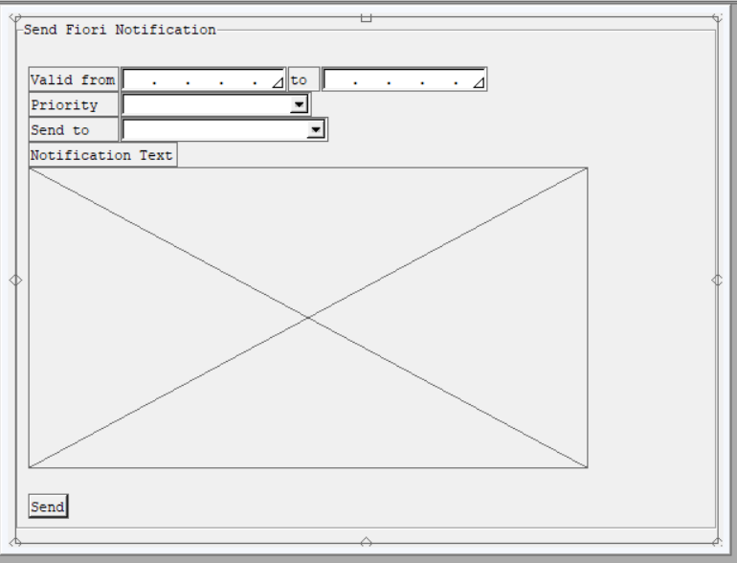

* 1. Text Elements  
       
     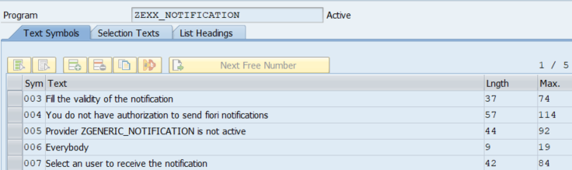

1. Report ZEXX_NOTIFICATION_SEND
   1. Body of the report:

|  |
| --- |
| *&---------------------------------------------------------------------* *& Report ZEXX_NOTIFICATION_SEND *&---------------------------------------------------------------------* *& This program must not be executed manually! *  The program can be executed via job or per the main program of notifications * /PBK/NOTIFICATION_SEND *&---------------------------------------------------------------------* REPORT zexx_notification_send.  DATA: zexx_nf        TYPE zexx_nf,       zexx_nf_nrecip TYPE zexx_nf_nrecip.  TYPES: ty_zexx_nf        TYPE STANDARD TABLE OF zexx_nf,        ty_zexx_nf_nrecip TYPE STANDARD TABLE OF zexx_nf_nrecip.  DATA: gt_users TYPE /iwngw/if_notif_provider=>ty_t_notification_recipient.  PARAMETERS: p_id  TYPE zexx_nf-notif_id,             p_pri TYPE /iwngw/notification_priority.  "used only for the job option SELECT-OPTIONS: s_id   FOR zexx_nf-notif_id MODIF ID job,                 s_user FOR zexx_nf_nrecip-user_id.  INITIALIZATION.  AT SELECTION-SCREEN OUTPUT.   PERFORM f_treat_screen.  START-OF-SELECTION.    PERFORM f_delete_outdated.   PERFORM f_get_users_to_send_nf.    IF sy-batch IS INITIAL.     PERFORM f_send_notification USING p_id.   ELSE.     PERFORM f_send_notification_batch.   ENDIF.   *&---------------------------------------------------------------------* *&      Form  F_DELETE_OUTDATED *&---------------------------------------------------------------------* FORM f_delete_outdated.    GET TIME STAMP FIELD DATA(lv_timestamp).   CONVERT TIME STAMP lv_timestamp TIME ZONE sy-zonlo INTO DATE DATA(lv_date) TIME DATA(lv_time).   lv_timestamp = lv_date && lv_time.    SELECT *     FROM zexx_nf     INTO TABLE @DATA(lt_zexx_nf)     WHERE valid_to < @lv_timestamp.   IF sy-subrc = 0.      SELECT notif_id, type_id       FROM /iwngw/notif       INTO TABLE @DATA(lt_/iwngw/notif)       FOR ALL ENTRIES IN @lt_zexx_nf       WHERE notif_id = @lt_zexx_nf-notif_id.     IF sy-subrc = 0.       LOOP AT lt_/iwngw/notif ASSIGNING FIELD-SYMBOL(<fs_/iwngw/notif>).         DELETE FROM /iwngw/notif    WHERE notif_id = <fs_/iwngw/notif>-notif_id.         DELETE FROM /iwngw/nrecip   WHERE notif_id = <fs_/iwngw/notif>-notif_id.         DELETE FROM /iwngw/ntype    WHERE type_id  = <fs_/iwngw/notif>-type_id.         DELETE FROM /iwngw/ntype_tt WHERE type_id  = <fs_/iwngw/notif>-type_id.       ENDLOOP.       COMMIT WORK AND WAIT.     ENDIF.      DELETE zexx_nf FROM TABLE lt_zexx_nf.     IF sy-subrc = 0.       COMMIT WORK AND WAIT.     ENDIF.    ENDIF.  ENDFORM. *&---------------------------------------------------------------------* *&      Form  F_SEND_NOTIFICATION *&---------------------------------------------------------------------* FORM f_send_notification  USING p_id TYPE zexx_nf-notif_id.  * " Service class /IWNGW/CL_IN_CO_NF_DATA   " Notification class to handle data /IWNGW/CL_COS_NOTIF_DBA   " Important class /IWNGW/CL_med_ntype_dba    DATA: lt_zexx_nf_job     TYPE STANDARD TABLE OF zexx_nf,         lt_zexx_nf_receips TYPE STANDARD TABLE OF zexx_nf_nrecip.    GET TIME STAMP FIELD DATA(lv_timestamp).   CONVERT TIME STAMP lv_timestamp TIME ZONE sy-zonlo INTO DATE DATA(lv_date) TIME DATA(lv_time).   lv_timestamp = lv_date && lv_time.    IF p_id IS INITIAL.     SELECT *       FROM zexx_nf       INTO TABLE @DATA(lt_zexx_nf)       WHERE valid_from <= @lv_timestamp AND valid_to >= @lv_timestamp.   ELSE.     SELECT *       FROM zexx_nf       INTO TABLE @lt_zexx_nf       WHERE notif_id = @p_id.   ENDIF.    IF lt_zexx_nf IS NOT INITIAL.     LOOP AT lt_zexx_nf ASSIGNING FIELD-SYMBOL(<fs_zexx_nf>).        IF p_id IS NOT INITIAL AND <fs_zexx_nf>-valid_from > lv_timestamp.         "it will be scheduled.         APPEND <fs_zexx_nf> TO lt_zexx_nf_job.         CONTINUE.       ENDIF.        PERFORM f_assign_values_nf_standard USING <fs_zexx_nf>                                           CHANGING lt_zexx_nf_receips.      ENDLOOP.      IF lt_zexx_nf_receips IS NOT INITIAL.       MODIFY zexx_nf_nrecip FROM TABLE lt_zexx_nf_receips.       COMMIT WORK.     ENDIF.      IF lt_zexx_nf_job IS NOT INITIAL.       PERFORM f_schedule_job USING lt_zexx_nf_job.     ENDIF.      "Notifications sent.     MESSAGE TEXT-002 TYPE 'S'.    ELSE.     "No notifications to send.     MESSAGE TEXT-001 TYPE 'S' DISPLAY LIKE 'E'.   ENDIF.  ENDFORM. *&---------------------------------------------------------------------* *&      Form  F_SCHEDULE_JOB *&---------------------------------------------------------------------* FORM f_schedule_job  USING lt_zexx_nf_job TYPE ty_zexx_nf.    DATA: lv_valid     TYPE c,         ls_params    TYPE pri_params,         lv_jobcount  TYPE tbtcjob-jobcount,         lv_released  TYPE btch0000-char1,         lv_jobname   TYPE tbtcjob-jobname,         lt_selection TYPE STANDARD TABLE OF rsparams,         ls_selection TYPE rsparams,         lv_plantime  TYPE tbtcjob-sdlstrttm,         lv_plandate  TYPE tbtcjob-sdlstrtdt.    CALL FUNCTION 'GET_PRINT_PARAMETERS'     EXPORTING       no_dialog              = abap_true     IMPORTING       out_parameters         = ls_params       valid                  = lv_valid     EXCEPTIONS       archive_info_not_found = 1       invalid_print_params   = 2       invalid_archive_params = 3       OTHERS                 = 4.   IF sy-subrc = 0.     lv_jobname = sy-repid.      CALL FUNCTION 'JOB_OPEN'       EXPORTING         jobname          = lv_jobname       IMPORTING         jobcount         = lv_jobcount       EXCEPTIONS         cant_create_job  = 1         invalid_job_data = 2         jobname_missing  = 3         OTHERS           = 4.     IF sy-subrc = 0.        "We will have alway only one       LOOP AT lt_zexx_nf_job INTO DATA(ls_zexx_nf_job).         ls_selection-selname = 'S_ID'.         ls_selection-kind    = 'S'. "Select Options = S         ls_selection-sign    = 'I'.         ls_selection-option  = 'EQ'.         ls_selection-low     = ls_zexx_nf_job-notif_id.         INSERT ls_selection INTO TABLE lt_selection.         CLEAR ls_selection.       ENDLOOP.        SUBMIT zexx_notification_send WITH SELECTION-TABLE lt_selection       VIA JOB lv_jobname       NUMBER lv_jobcount       TO SAP-SPOOL WITHOUT SPOOL DYNPRO       SPOOL PARAMETERS ls_params       AND RETURN.        "Job will be scheduled according to the System Time Zone       CONVERT TIME STAMP ls_zexx_nf_job-valid_from TIME ZONE 'UTC-1' INTO DATE lv_plandate TIME lv_plantime.        CALL FUNCTION 'JOB_CLOSE'         EXPORTING           jobcount             = lv_jobcount           jobname              = lv_jobname           sdlstrtdt            = lv_plandate           sdlstrttm            = lv_plantime           strtimmed            = abap_true         IMPORTING           job_was_released     = lv_released         EXCEPTIONS           cant_start_immediate = 1           invalid_startdate    = 2           jobname_missing      = 3           job_close_failed     = 4           job_nosteps          = 5           job_notex            = 6           lock_failed          = 7           invalid_target       = 8           OTHERS               = 9.        IF sy-subrc NE 0.         MESSAGE TEXT-003 TYPE 'E'. "error       ENDIF.     ENDIF.   ENDIF.  ENDFORM. *&---------------------------------------------------------------------* *&      Form  F_SEND_NOTIFICATION_BATCH *&---------------------------------------------------------------------* FORM f_send_notification_batch.    DATA: lt_zexx_nf_receips TYPE STANDARD TABLE OF zexx_nf_nrecip.    IF s_id IS NOT INITIAL.     SELECT *       FROM zexx_nf       INTO TABLE @DATA(lt_zexx_nf)       WHERE notif_id IN @s_id.      IF lt_zexx_nf IS NOT INITIAL.       LOOP AT lt_zexx_nf ASSIGNING FIELD-SYMBOL(<fs_zexx_nf>).          PERFORM f_assign_values_nf_standard USING <fs_zexx_nf>                                             CHANGING lt_zexx_nf_receips.          IF lt_zexx_nf_receips IS NOT INITIAL.           MODIFY zexx_nf_nrecip FROM TABLE lt_zexx_nf_receips.           COMMIT WORK.         ENDIF.        ENDLOOP.        "Notifications sent.       MESSAGE TEXT-002 TYPE 'S'.        LOOP AT lt_zexx_nf ASSIGNING <fs_zexx_nf>.         WRITE: / <fs_zexx_nf>-notif_id, space, <fs_zexx_nf>-valid_from, space , <fs_zexx_nf>-valid_to, space, <fs_zexx_nf>-notification.       ENDLOOP.      ELSE.       "No notifications to send.       MESSAGE TEXT-001 TYPE 'S' DISPLAY LIKE 'E'.     ENDIF.    ELSE.     "No new Notifications     MESSAGE TEXT-007 TYPE 'S'.   ENDIF.  ENDFORM. *&---------------------------------------------------------------------* *&      Form  F_ASSIGN_VALUES_NF_STANDARD *&---------------------------------------------------------------------* FORM f_assign_values_nf_standard  USING    ls_zexx_nf        TYPE zexx_nf                                   CHANGING lt_zexx_nf_nrecip TYPE ty_zexx_nf_nrecip.    DATA: lt_nf               TYPE /iwngw/if_notif_provider=>ty_t_notification,         lt_parameter        TYPE /iwngw/if_notif_provider=>ty_t_notification_param_bundle,         lt_parameter_values TYPE /iwngw/if_notif_provider=>ty_t_notification_parameter,         ls_nf               TYPE LINE OF /iwngw/if_notif_provider=>ty_t_notification,         ls_parameter        TYPE LINE OF /iwngw/if_notif_provider=>ty_t_notification_param_bundle,         ls_parameter_values TYPE LINE OF /iwngw/if_notif_provider=>ty_t_notification_parameter,         lv_system_uuid      TYPE REF TO if_system_uuid.    DATA: ls_zexx_nf_receips TYPE zexx_nf_nrecip.    zcl_generic_fiori_notification=>gv_generic_nf = ls_zexx_nf-notification.    lv_system_uuid = cl_uuid_factory=>create_system_uuid( ).    TRY.       ls_nf-id                       = ls_zexx_nf-notif_id. "lv_system_uuid->create_uuid_x16( ).     CATCH cx_uuid_error.   ENDTRY.    ls_nf-type_key                 = 'ZGENERIC_NOTIFICATION'.   ls_nf-type_version             = '9'.   ls_nf-recipients               = gt_users[].   ls_nf-priority                 = p_pri.    ls_parameter_values-name         = 'message'. "Check Class and Method: ZCL_GENERIC_FIORI_NOTIFICATION~/IWNGW/IF_NOTIF_PROVIDER~GET_NOTIFICATION_TYPE_TEXT   ls_parameter_values-type         = 'Edm.String'.   ls_parameter_values-value        = ls_zexx_nf-notification.   ls_parameter_values-is_sensitive = abap_false.   APPEND ls_parameter_values TO lt_parameter_values. CLEAR: ls_parameter_values.    ls_parameter_values-name         = 'user'. "Check Class and Method: ZCL_GENERIC_FIORI_NOTIFICATION~/IWNGW/IF_NOTIF_PROVIDER~GET_NOTIFICATION_TYPE_TEXT   ls_parameter_values-type         = 'Edm.String'.   ls_parameter_values-value        = sy-uname.   ls_parameter_values-is_sensitive = abap_false.   APPEND ls_parameter_values TO lt_parameter_values. CLEAR: ls_parameter_values.    ls_parameter-language            = sy-langu.   ls_parameter-parameters          = lt_parameter_values.   APPEND ls_parameter TO lt_parameter.    ls_nf-parameters = lt_parameter[].    APPEND ls_nf TO lt_nf.    TRY.        /iwngw/cl_notification_api=>create_notifications(         EXPORTING           iv_provider_id  = 'ZGENERIC_NOTIFICATION'           it_notification = lt_nf ).        LOOP AT gt_users INTO DATA(ls_user).         ls_zexx_nf_receips-notif_id = ls_nf-id.         ls_zexx_nf_receips-user_id  = ls_user-id.         APPEND ls_zexx_nf_receips TO lt_zexx_nf_nrecip. CLEAR ls_zexx_nf_receips.       ENDLOOP.      CATCH /iwngw/cx_notification_api INTO DATA(lrx_api).       MESSAGE TEXT-008 TYPE 'S' DISPLAY LIKE 'E'.       LEAVE LIST-PROCESSING.   ENDTRY.  ENDFORM. *&---------------------------------------------------------------------* *&      Form  F_TREAT_SCREEN *&---------------------------------------------------------------------* FORM f_treat_screen .   LOOP AT SCREEN.     IF screen-group1 = 'JOB'.       screen-invisible = 1.       screen-active = 0.       MODIFY SCREEN.     ENDIF.   ENDLOOP. ENDFORM. *&---------------------------------------------------------------------* *&      Form  F_GET_USERS_TO_SEND_NF *&---------------------------------------------------------------------* FORM f_get_users_to_send_nf .    SELECT DISTINCT uname          FROM agr_users          INTO TABLE gt_users          WHERE ( agr_name = 'ZNTUSERPRODU'             OR agr_name = 'ZNTUSERCONSU'             OR agr_name = 'ZNTNPDEV'             OR agr_name = 'ZNTHUBADM'             OR agr_name = 'ZNTBEPADM' )            AND from_dat <= sy-datum             AND to_dat >= sy-datum             AND uname IN s_user.   IF sy-subrc <> 0.     "There are no users to receive notifications. Check the roles.     MESSAGE TEXT-004 TYPE 'S' DISPLAY LIKE 'E'.     LEAVE LIST-PROCESSING.   ENDIF.  ENDFORM. |

* 1. Text elements:  
       
     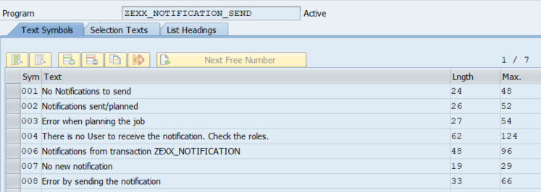

1. Provider Configuration at SPRO transaction  
     
   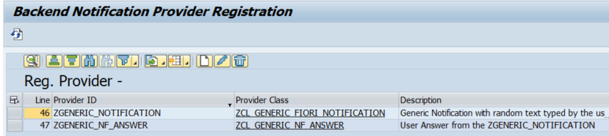  
     
   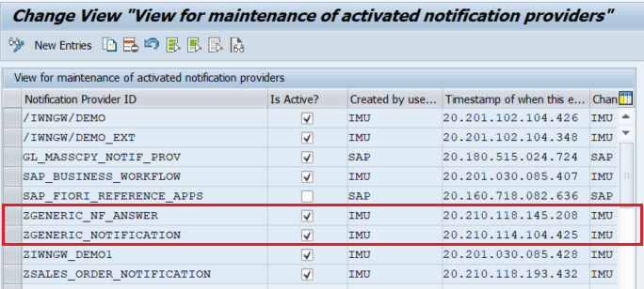
2. Class ZCL_GENERIC_FIORI_NOTIFICATION
   1. Assign the interface /IWNGW/IF_NOTIF_PROVIDER to the class
   2. Method /IWNGW/IF_NOTIF_PROVIDER~HANDLE_ACTION: This method will perform the logic after the user decides if he will accept the question of the notification or not.

|  |
| --- |
| METHOD /iwngw/if_notif_provider~handle_action.    DATA: ls_zexx_nf_nrecip TYPE zexx_nf_nrecip.    "Update the DB according with the button the user has clicked   CASE iv_action_key.     WHEN 'Accept'.       SELECT SINGLE * FROM zexx_nf_nrecip INTO ls_zexx_nf_nrecip WHERE notif_id = iv_notification_id AND user_id = sy-uname.       IF sy-subrc = 0.         ls_zexx_nf_nrecip-accepted = abap_true.         UPDATE zexx_nf_nrecip FROM ls_zexx_nf_nrecip.       ENDIF.        send_nf_answer( EXPORTING iv_nf_id = iv_notification_id                                 iv_action_key = iv_action_key ).      WHEN 'Reject'.       SELECT SINGLE * FROM zexx_nf_nrecip INTO ls_zexx_nf_nrecip WHERE notif_id = iv_notification_id AND user_id = sy-uname.       IF sy-subrc = 0.         ls_zexx_nf_nrecip-rejected = abap_true.         UPDATE zexx_nf_nrecip FROM ls_zexx_nf_nrecip.       ENDIF.        send_nf_answer( EXPORTING iv_nf_id = iv_notification_id                                 iv_action_key = iv_action_key ).      WHEN 'Maybe'.       SELECT SINGLE * FROM zexx_nf_nrecip INTO ls_zexx_nf_nrecip WHERE notif_id = iv_notification_id AND user_id = sy-uname.       IF sy-subrc = 0.         ls_zexx_nf_nrecip-maybe = abap_true.         UPDATE zexx_nf_nrecip FROM ls_zexx_nf_nrecip.       ENDIF.        send_nf_answer( EXPORTING iv_nf_id = iv_notification_id                                 iv_action_key = iv_action_key ).      WHEN OTHERS.   ENDCASE.    es_result-success = abap_true.  ENDMETHOD. |

* 1. Method /IWNGW/IF_NOTIF_PROVIDER~HANDLE_BULK_ACTION: This action will be performed when the user decides do accept all, reject all and so on. To clarify take a look at this picture:  
       
     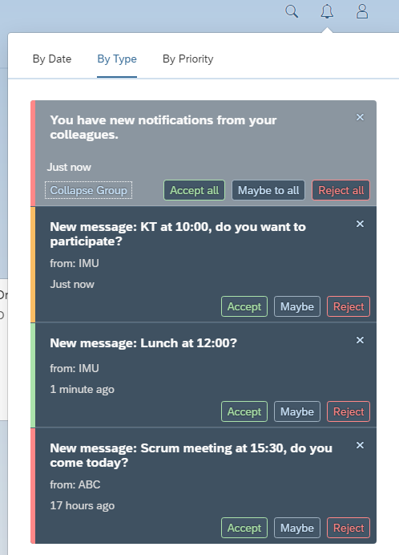

|  |
| --- |
| METHOD /iwngw/if_notif_provider~handle_bulk_action.    "Bulk actions are actions like: Approve all, reject all.   TYPES: BEGIN OF ty_ids,            id TYPE zexx_nf_nrecip-notif_id,          END OF ty_ids.    DATA: lt_ids TYPE STANDARD TABLE OF ty_ids,         ls_ids TYPE ty_ids.    CHECK it_bulk_notif IS NOT INITIAL.    LOOP AT it_bulk_notif ASSIGNING FIELD-SYMBOL(<fs_bulk_notif>).     ls_ids-id = <fs_bulk_notif>-id.     APPEND ls_ids TO lt_ids.   ENDLOOP.    SELECT *     FROM zexx_nf_nrecip     INTO TABLE @DATA(lt_zexx_nf_nrecip)     FOR ALL ENTRIES IN @lt_ids     WHERE notif_id = @lt_ids-id       AND user_id = @sy-uname.    CHECK sy-subrc = 0.    LOOP AT it_bulk_notif ASSIGNING <fs_bulk_notif>.     READ TABLE lt_zexx_nf_nrecip ASSIGNING FIELD-SYMBOL(<fs_zexx_nf_nrecip>) WITH KEY notif_id = <fs_bulk_notif>-id.     IF sy-subrc = 0.       CASE <fs_bulk_notif>-action_key.         WHEN 'Accept'.           <fs_zexx_nf_nrecip>-accepted = abap_true.            send_nf_answer( EXPORTING iv_nf_id = <fs_bulk_notif>-id                                     iv_action_key = <fs_bulk_notif>-action_key ).          WHEN 'Reject'.           <fs_zexx_nf_nrecip>-rejected = abap_true.            send_nf_answer( EXPORTING iv_nf_id = <fs_bulk_notif>-id                                     iv_action_key = <fs_bulk_notif>-action_key ).          WHEN 'Maybe'.           <fs_zexx_nf_nrecip>-maybe = abap_true.            send_nf_answer( EXPORTING iv_nf_id = <fs_bulk_notif>-id                                     iv_action_key = <fs_bulk_notif>-action_key ).          WHEN OTHERS.       ENDCASE.     ENDIF.   ENDLOOP.    UPDATE zexx_nf_nrecip FROM TABLE lt_zexx_nf_nrecip.  ENDMETHOD. |

* 1. Method /IWNGW/IF_NOTIF_PROVIDER~GET_NOTIFICATION_TYPE_TEXT

|  |  |
| --- | --- |
| **Text** | **Table Source** |
| New message: &1 | &1: {message} |
| from: &1 | &1: {user} |

|  |
| --- |
| METHOD /iwngw/if_notif_provider~get_notification_type_text.    DATA: lv_text     TYPE string,         lv_subtitle TYPE string.    DATA: ls_action_text TYPE LINE OF /iwngw/if_notif_provider=>ty_t_notification_action_text.    lv_text = TEXT-001. "New message: &1    REPLACE '&1' WITH '{message}' INTO lv_text.    lv_subtitle = TEXT-003. "from: &1    REPLACE '&1' WITH '{user}' INTO lv_subtitle.    es_type_text-subtitle            = lv_subtitle.   es_type_text-template_public     = lv_text.   es_type_text-template_grouped    = TEXT-002. "You have new notifications.   es_type_text-template_sensitive  = lv_text.    ls_action_text-action_key   = 'Accept'.   ls_action_text-display_text = TEXT-004. "Accept   ls_action_text-display_text_grouped = TEXT-007. "Accept all   APPEND ls_action_text TO et_action_text.    ls_action_text-action_key   = 'Maybe'.   ls_action_text-display_text = TEXT-005. "Maybe   ls_action_text-display_text_grouped = TEXT-008. "Maybe to all   APPEND ls_action_text TO et_action_text.    ls_action_text-action_key   = 'Reject'.   ls_action_text-display_text = TEXT-006. "Reject   ls_action_text-display_text_grouped = TEXT-009. "Reject all   APPEND ls_action_text TO et_action_text.  ENDMETHOD. |

* 1. Method /IWNGW/IF_NOTIF_PROVIDER~GET_NOTIFICATION_TYPE

|  |
| --- |
| METHOD /iwngw/if_notif_provider~get_notification_type.    DATA: ls_action TYPE LINE OF /iwngw/if_notif_provider=>ty_t_notification_action.    es_notification_type-is_groupable = abap_true.   es_notification_type-type_key     = iv_type_key.   es_notification_type-version      = iv_type_version.    ls_action-action_key = 'Accept'.   ls_action-nature = /iwngw/if_notif_provider=>gcs_action_natures-positive.   APPEND ls_action TO et_notification_action.    ls_action-action_key = 'Maybe'.   ls_action-nature = /iwngw/if_notif_provider=>gcs_action_natures-neutral.   APPEND ls_action TO et_notification_action.    ls_action-action_key = 'Reject'.   ls_action-nature = /iwngw/if_notif_provider=>gcs_action_natures-negative.   APPEND ls_action TO et_notification_action.   ENDMETHOD. |

* 1. Method SEND_NF_ANSWER

|  |
| --- |
| METHOD send_nf_answer.    DATA: lt_nf               TYPE /iwngw/if_notif_provider=>ty_t_notification,         ls_nf               TYPE LINE OF /iwngw/if_notif_provider=>ty_t_notification,         lt_user             TYPE STANDARD TABLE OF /iwngw/if_notif_provider=>ty_s_notification_recipient,         ls_user             TYPE /iwngw/if_notif_provider=>ty_s_notification_recipient,         lt_parameter_values TYPE /iwngw/if_notif_provider=>ty_t_notification_parameter,         ls_parameter_values TYPE LINE OF /iwngw/if_notif_provider=>ty_t_notification_parameter,         ls_parameter        TYPE LINE OF /iwngw/if_notif_provider=>ty_t_notification_param_bundle,         lt_parameter        TYPE /iwngw/if_notif_provider=>ty_t_notification_param_bundle.    TRY.       DATA(lv_system_uuid) = cl_uuid_factory=>create_system_uuid( ).       ls_nf-id             = lv_system_uuid->create_uuid_x16( ).     CATCH cx_uuid_error.       EXIT.   ENDTRY.    SELECT SINGLE *          FROM zexx_nf          INTO @DATA(ls_zexx_nf)          WHERE notif_id = @iv_nf_id.   CHECK sy-subrc = 0.    ls_user-id = ls_zexx_nf-created_by.   APPEND ls_user TO lt_user. CLEAR ls_user.    ls_nf-type_key                 = 'ZGENERIC_NOTIFICATION'.   ls_nf-type_version             = '9'.   ls_nf-recipients               = lt_user[].    "Answer of the user: "X" to notification "Y": "Z".    ls_parameter_values-name         = 'notification'.   ls_parameter_values-type         = 'Edm.String'.   ls_parameter_values-value        = ls_zexx_nf-notification.   ls_parameter_values-is_sensitive = abap_false.   APPEND ls_parameter_values TO lt_parameter_values. CLEAR: ls_parameter_values.    ls_parameter_values-name         = 'user'.   ls_parameter_values-type         = 'Edm.String'.   ls_parameter_values-value        = sy-uname.   ls_parameter_values-is_sensitive = abap_false.   APPEND ls_parameter_values TO lt_parameter_values. CLEAR: ls_parameter_values.    ls_parameter_values-name         = 'decision'.   ls_parameter_values-type         = 'Edm.String'.   ls_parameter_values-value        = iv_action_key.   ls_parameter_values-is_sensitive = abap_false.   APPEND ls_parameter_values TO lt_parameter_values. CLEAR: ls_parameter_values.    ls_parameter-language            = sy-langu.   ls_parameter-parameters          = lt_parameter_values.   APPEND ls_parameter TO lt_parameter.    ls_nf-parameters = lt_parameter[].    APPEND ls_nf TO lt_nf.    TRY.       /iwngw/cl_notification_api=>create_notifications(         EXPORTING           iv_provider_id  = 'ZGENERIC_NF_ANSWER' " class ZCL_GENERIC_NF_ANSWER           it_notification = lt_nf ).        COMMIT WORK AND WAIT.      CATCH /iwngw/cx_notification_api INTO DATA(lrx_api).       EXIT.   ENDTRY.  ENDMETHOD. |

* 1. Text elements  
     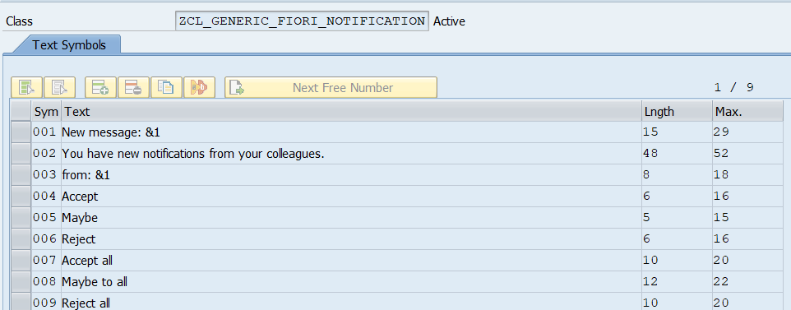

1. Class ZCL_GENERIC_NF_ANSWER
   1. Implement the interface /IWNGW/IF_NOTIF_PROVIDER
   2. Method /IWNGW/IF_NOTIF_PROVIDER~GET_NOTIFICATION_TYPE_TEXT

|  |  |
| --- | --- |
| **Text** | **Table Source** |
| Answer of notification: &1 | &1: {notification} |
| &2, from user: &3 | &2: {decision}  &3: {user} |

|  |
| --- |
| METHOD /iwngw/if_notif_provider~get_notification_type_text.    DATA: lv_text     TYPE string,         lv_subtitle TYPE string.    lv_text = TEXT-001. "Answer of notification: &1   lv_subtitle = TEXT-003. "&2, from user: &3.    REPLACE '&1' WITH '{notification}' INTO lv_text.   REPLACE '&2' WITH '{decision}' INTO lv_subtitle.   REPLACE '&3' WITH '{user}' INTO lv_subtitle.    es_type_text-template_public     = lv_text.   es_type_text-template_grouped    = TEXT-002. "Answers of the generic notifications   es_type_text-template_sensitive  = lv_text.   es_type_text-subtitle  = lv_subtitle.  ENDMETHOD. |

* 1. Method /IWNGW/IF_NOTIF_PROVIDER~GET_NOTIFICATION_TYPE

|  |
| --- |
| METHOD /IWNGW/IF_NOTIF_PROVIDER~GET_NOTIFICATION_TYPE.    es_notification_type-is_groupable = abap_true.   es_notification_type-type_key     = iv_type_key.   es_notification_type-version      = iv_type_version.  ENDMETHOD. |

* 1. Text elements:

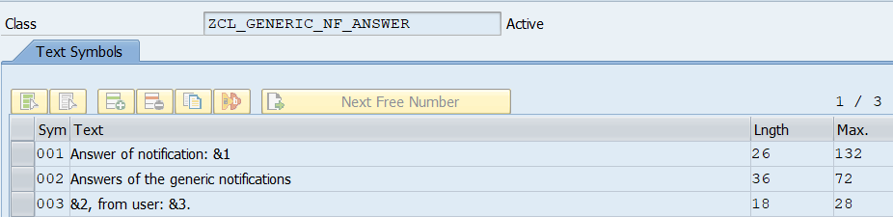

Conclusion

The SAP Fiori Notifications is a powerful tool to catch the attention of the users. In one place it is possible to configure the activities that should be performed in the system, categorized by priority, date or type.

The notification can even be a simple message or a important decision to be made, for example, an approval of purschase requisitions or sales orders.

It is well connected with standard workflows and can be very well customizable.

References

The content of this article was based in some SAP Notes, that were along the documentation described and the Fiori Guidelines.

Table of note references:

|  |  |
| --- | --- |
| [2488945](https://launchpad.support.sap.com/#/notes/2488945) | How to setup notifications in Fiori 2.0 |
| [2356153](https://launchpad.support.sap.com/#/notes/2356153) | Business Workflow Extensions - Version 2 |
| [2456330](https://launchpad.support.sap.com/#/notes/2456330) | How to configure Fiori Launchpad step-by-step |
| [2424054](https://launchpad.support.sap.com/#/notes/2424054) | How to setup My Inbox 2.0 app |
| [2729492](https://launchpad.support.sap.com/#/notes/2729492) | Configuring notifications in Fiori Launchpad and known restrictions |

Table of link references:

|  |
| --- |
| <https://wiki.scn.sap.com/wiki/display/SAPMOB/How+to+Setup+Notifications+in+Fiori+2.0+step-by-step> |
| <https://experience.sap.com/fiori-design-web/notification-center/> |